Session 21 - Inheritance & Polymorphism: Task Report

Task 1: Product Class
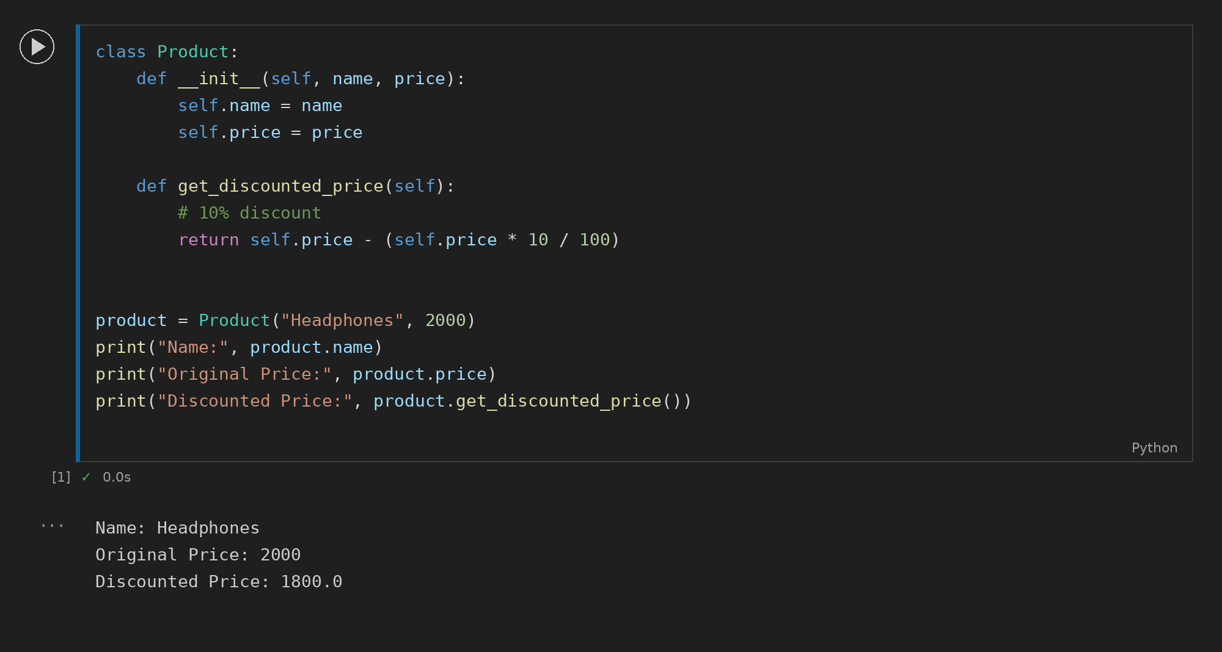

Task 2: Electronics Subclass
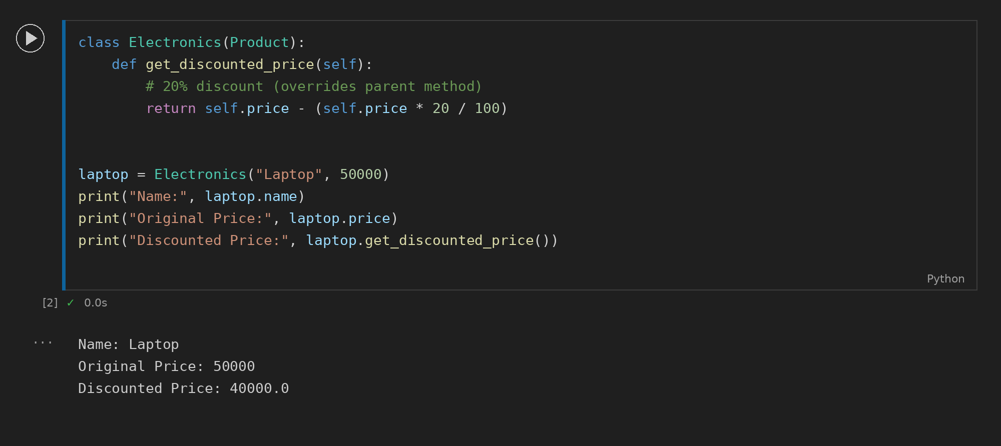

Task 3: Polymorphism Function
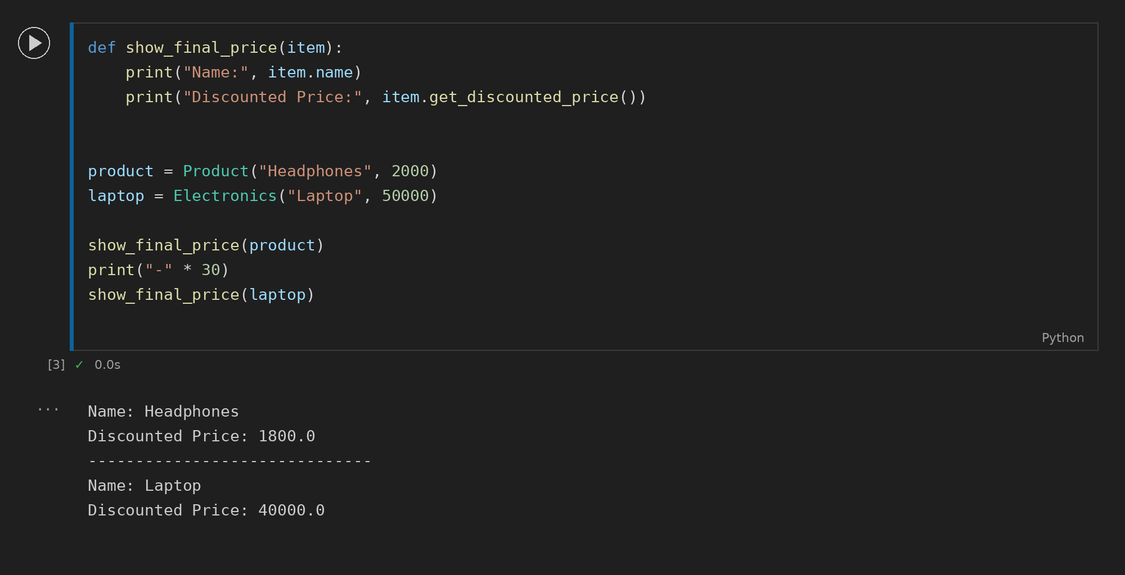

Task 4: Ticket and PremiumTicket
